Downloading Images:

Why:

It’s faster to have them on a hard drive than Google Drive.

Google Drive compresses files; they come out worse quality.

Access to the most updated version that the British Library has available.

If the quality isn’t good enough we can re-download them quickly.

How:

Go to the mac computer next to the one we met at (preferably before 10)

Download the contents of the “Stamatov_Downloads” to “Save_Here.”

Double click the “Learn_Batch.command” file.

Come back collect a folder called “Articles_names_abolition” later.

Might have to send people to check on it routinely for a day.

Recognizing Text:

Step 1: Double Click “OCR_Automation.”

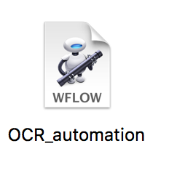

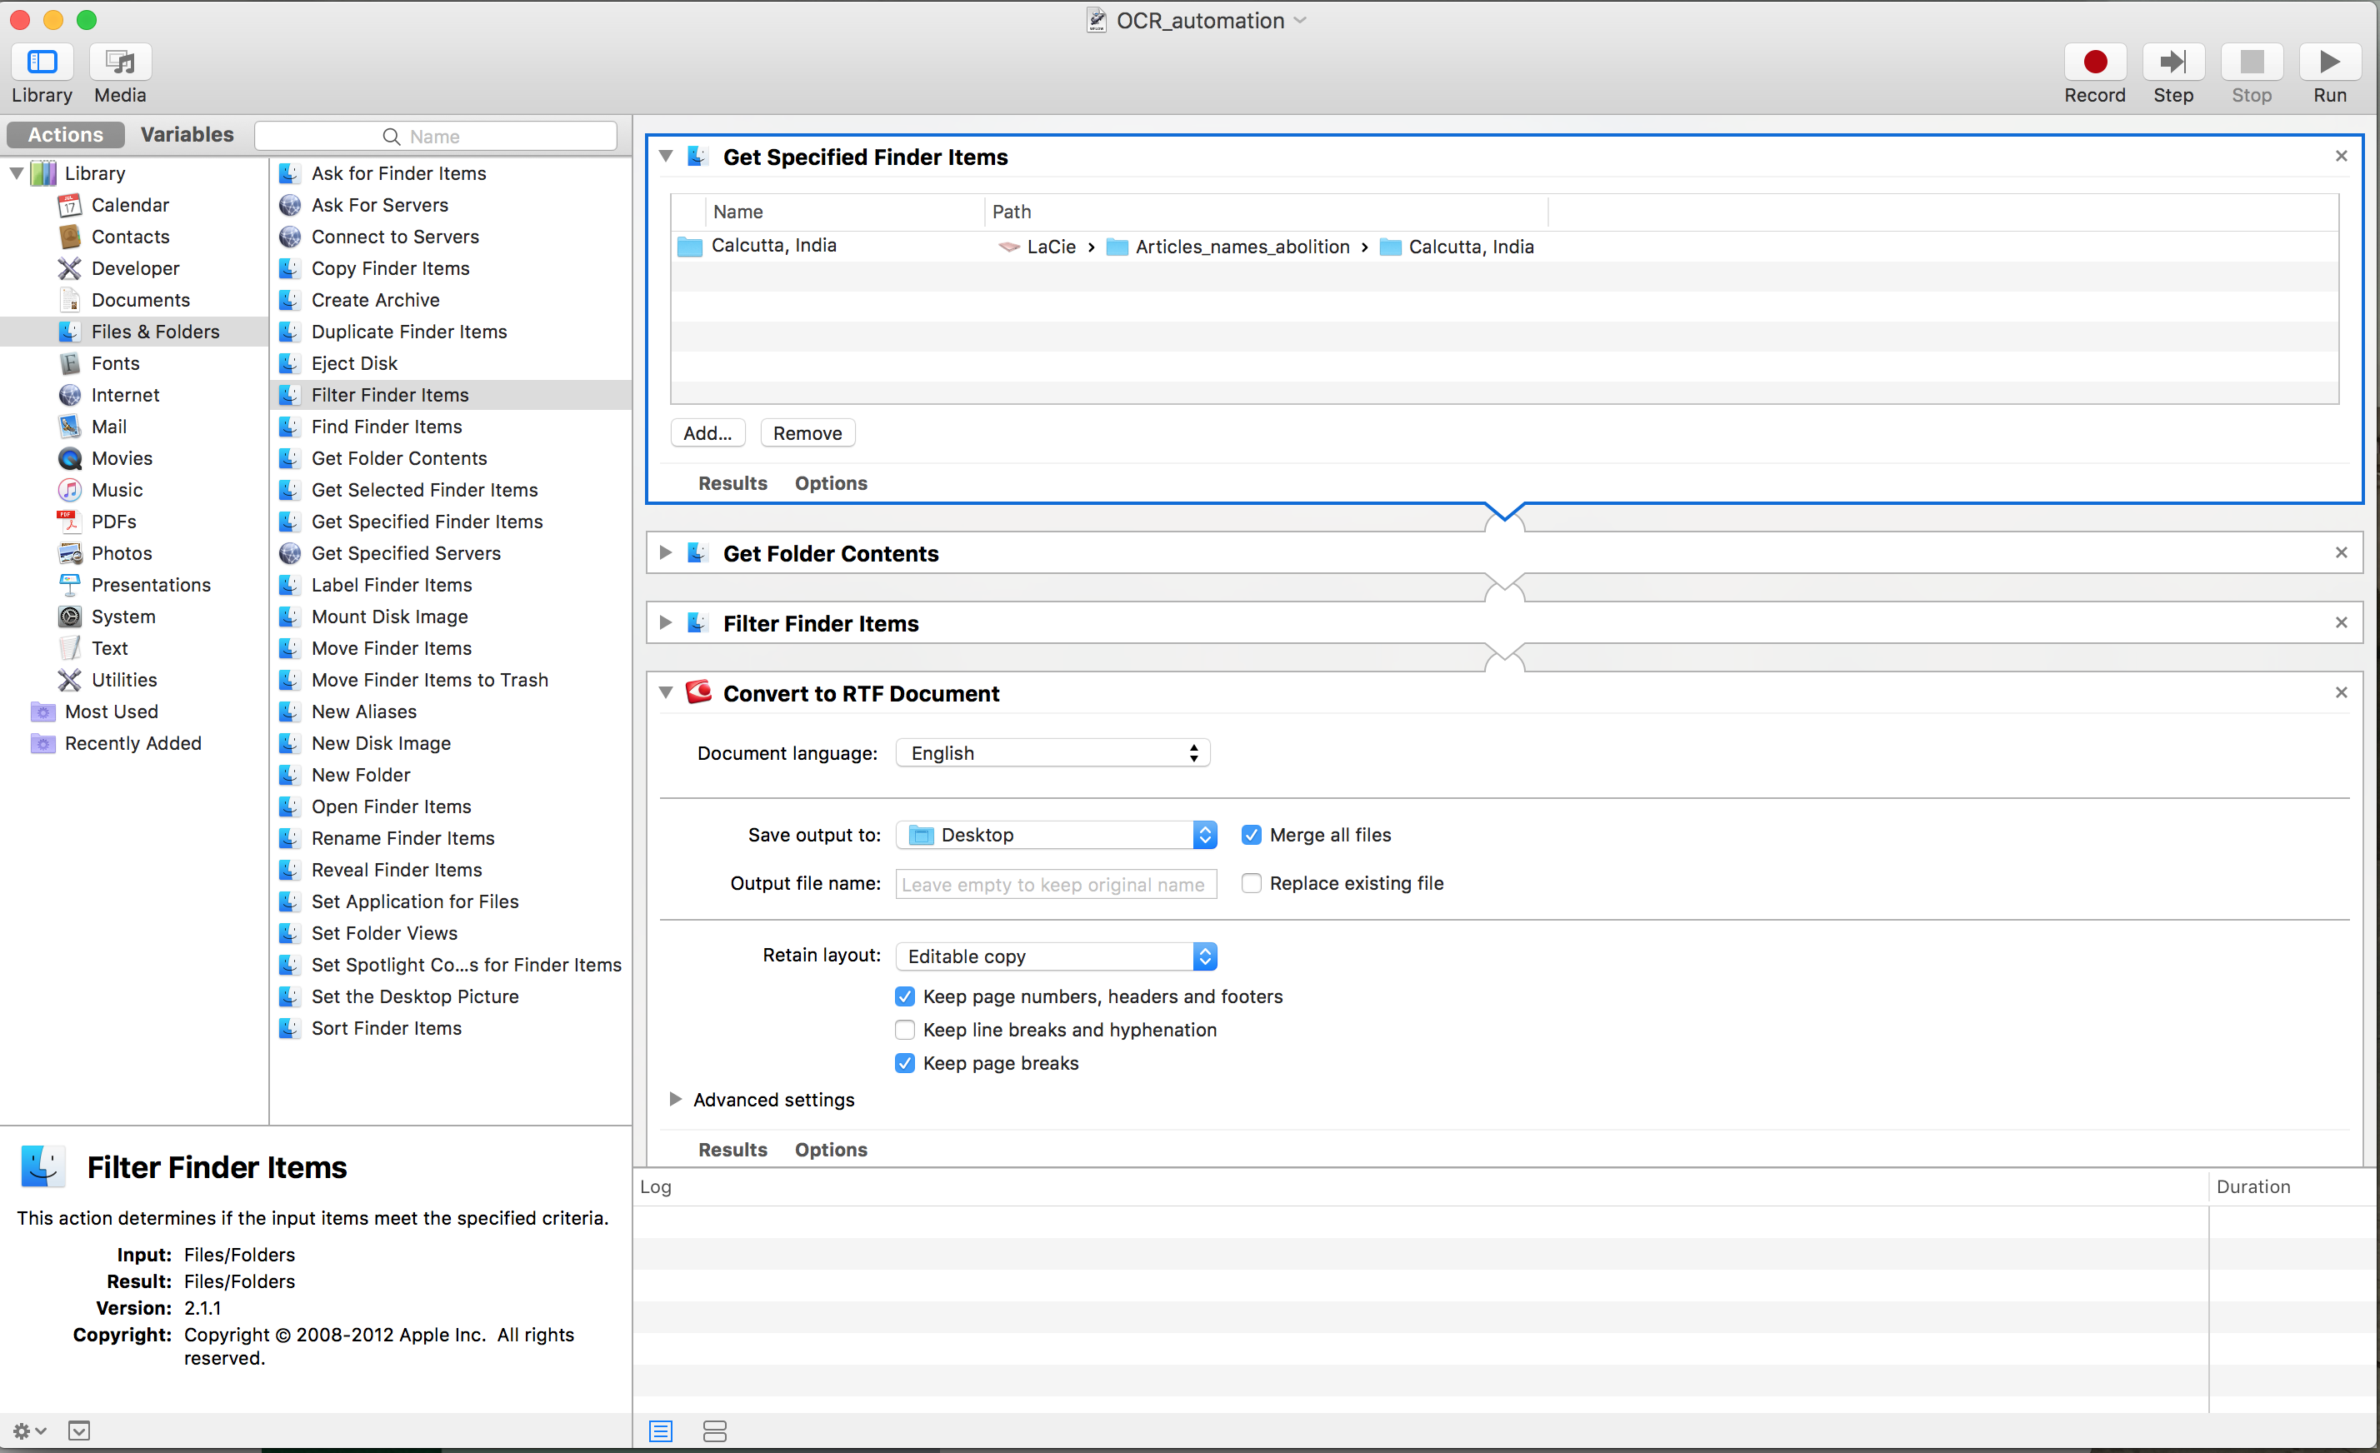

Step 2: Select a city/location folder.

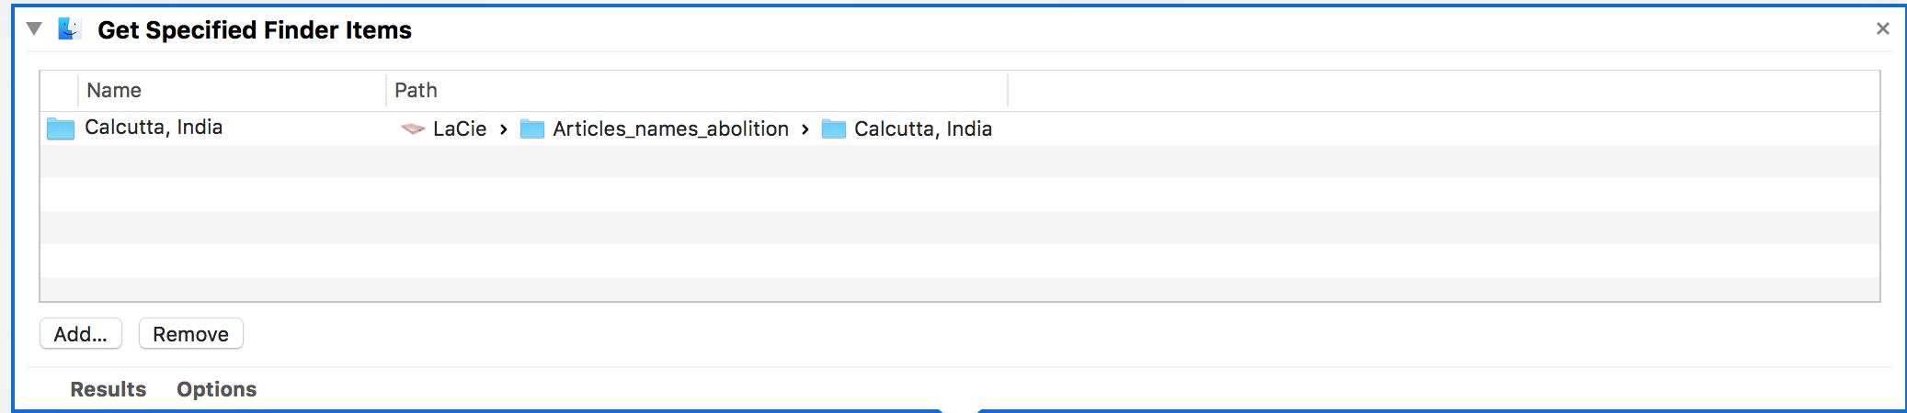

Click “Add…” and select the folder in the finder window

Step 3: Choose an output folder.

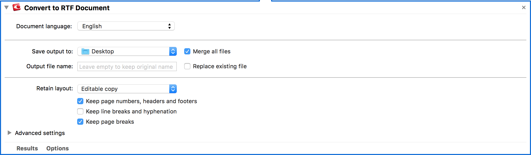

Step 4: Hit run and wait for abbyy to convert them to rtf

This might take a while so you can go do anything in the mean time as long as you check up on it every now and then.

Do not worry about corrections for now. All we are doing is running Abbyy on them



Step 5: Upload results to Google Drive

If possible create a folder of your own in the drive and name it using this format:

Yourname_Results

Step 6: Create headers

Go on the new .rtf file that was generated and try as much as possible to leave a comment or quick note on top of each Article stating the date it was published and the publisher it came from.

I would prefer a format like mm/dd/yyyy-publisher